Aim-

1. Small code snippets for programs like Hello World, and Calculator using TypeScript.

2. Inheritance example using TypeScript.

3. Access Modifiers example using TypeScript.

Theory-

TypeScript Access Modifiers

Like other programming languages, Typescript allows us to use access modifiers at the class level. It gives direct access control to the class member. These class members are functions and properties. We can use class members inside their own class, anywhere outside the class, or within its child or derived class.

The access modifier increases the security of the class members and prevents them from invalid use. We can also use it to control the visibility of data members of a class. If the class does not have to be set any access modifier, TypeScript automatically sets the public access modifier to all class members.

The TypeScript access modifiers are of three types. These are:

1. Public
2. Private
3. Protected.

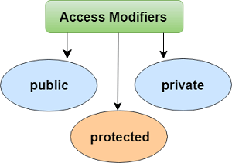

Output-

1. Small code snippets for programs like Hello World, and Calculator using TypeScript.

console.log("Hello World!!");

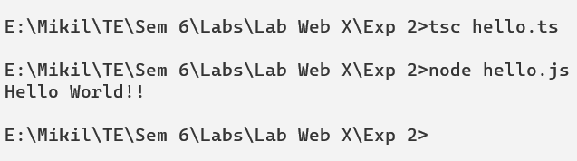

var a:number = 20;

var b:number = 10;

function add(a:number, b:number):number{

return a+b;

}

function sub(a:number, b:number):number{

return a-b;

}

function div(a:number, b:number):number{

return a/b;

}

function mul(a:number, b:number):number{

return a\*b;

}

console.log(add(a,b));

console.log(sub(a,b));

console.log(div(a,b));

console.log(mul(a,b));

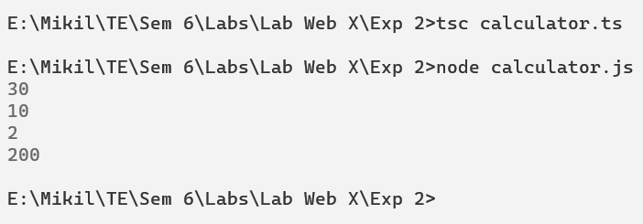

2. Inheritance example using TypeScript.

class Person {

firstName: string;

lastName: string;

constructor(firstName, lastName) {

this.firstName = firstName;

this.lastName = lastName;

}

}

class Employee extends Person {

employeeID: number;

constructor(firstName, lastName, employeID) {

super(firstName, lastName);

this.employeeID = employeID;

}

}

class Manager extends Employee{

department :string;

constructor(firstName, lastName, employeID, department) {

super(firstName, lastName, employeID);

this.department = department;

}

}

let manager = new Manager('Mehul','Sharma', 123, 'Sales');

console.log("Name of manager: "+manager.firstName + manager.lastName);

console.log("Emplpoyee ID: "+ manager.employeeID);

console.log("Manager's Department: "+manager.department);

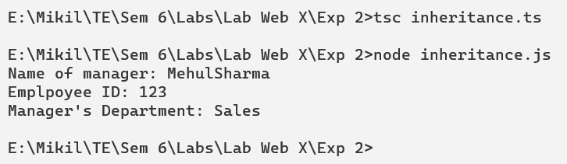

3. Access Modifiers example using TypeScript.

class Student{

public name :string = "Mikil";

protected roll :number = 37;

private accNo :number = 12345;

getAccNo()

{

return this.accNo;

}

}

class Person extends Student{

constructor()

{

super();

}

display()

{

return "Roll number of student: "+this.roll;

}

}

let s :Student = new Student();

let p :Person = new Person();

console.log("Name of student: "+s.name);

console.log(p.display());

console.log("Account number of student: "+s.getAccNo());

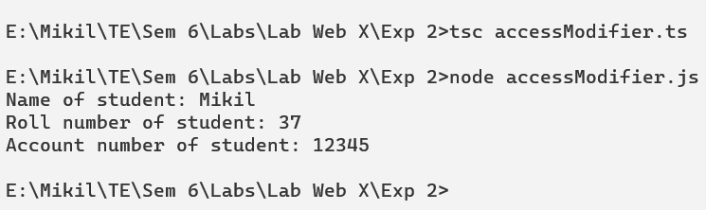

Conclusion-

Thus we successfully learned the basics of typescript and performed various experiments. We implemented different programs in typescript to understand the programming language.